**Port Exhauster demo**  
**Command-line example:**java -jar portexhauster.jar --serverport 8080 --numclientconns 5 --clientdelayMS 60000  
  
This starts 5 client threads, each connecting to the server on port 8080. The clients will wait 60 seconds before closing their connection to the server.  
  
**Capture from System Internals TCPView: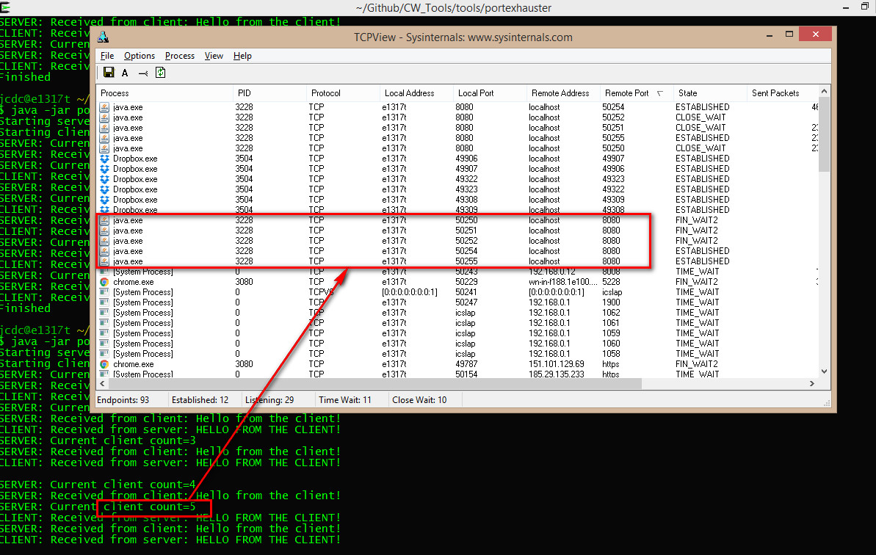 Determine the current TCP port range:**C:\Users\Administrator>netsh int ipv4 show dynamicportrange tcp

Protocol tcp Dynamic Port Range

---------------------------------

Start Port : 49152

Number of Ports : 16384 **Temporarily increase the current TCP port range:**C:\Users\Administrator>netsh int ipv4 set dynamicport tcp start=10000 num=55535

Ok.

**NOTE: This change takes effect immediately. No need to restart. No need to reboot. This is about three times larger than the default.  
  
Reset to the original TCP port range:**netsh int ipv4 set dynamicport tcp start=49152 num=16384 **Troubleshooting port exhaustion:**o<https://blogs.technet.microsoft.com/askds/2008/10/29/port-exhaustion-and-you-or-why-the-netstat-tool-is-your-friend/>  
o <https://msdn.microsoft.com/en-us/library/aa560610(v=bts.20).aspx> (mentions the registry locationHKEY_LOCAL_MACHINE\SYSTEM\CurrentControlSet\Services\Tcpip\Parameters).

*JeremyC 21-06-2017* **END**